TAGORE DENTAL COLLEGE AND HOSPITAL
DEPARTMENT OF ORAL AND MAXILLOFACIAL SURGERY

WORKSHOP ON
“BIOETHICS AND RESEARCH INTEGRITY”
DATE: 17.12.2020

Venue:
Conducted online through zoom application.

DEPARTMENT OF ORAL AND MAXILLOFACIAL SURGERY
TAGORE DENTAL COLLEGE AND HOSPITAL
MELAKOTTAIYUR POST, RATHINAMANGALAM
CHENNAI – 600127
PH: 044 – 3010 2222, EXTN: 228 / 230
EMAIL ID: maxfacs@tagoredch.in

PROF.M.MALA DR.CHITRAA R. CHANDRAN
CHAIRPERSON PRINCIPAL

ORGANIZING COMMITTEE:
PROF.DR.S.JIMSON
DR.J.PARTHIBAN
DR.B.LOKESH
DR.B.ANANDH
DR.MEERAN SHARIF
DR.VINAY SUNDAR
DR.ISRAEL NATHANAEL

REPORT ON “BIOETHICS AND RESEARCH INTEGRITY WORKSHOP “– 17th December 2020”

Title of the CDE Program: BIOETHICS AND RESEARCH INTEGRITY WORKSHOP (VIRTUAL)
Organizer:
Department of Oral & Maxillofacial Surgery
Tagore Dental College & Hospital
&
Association of Oral and Maxillofacial Surgery
Tamil Nadu & Puducherry Branch.

Date: 17th December, 2020
Learning Outcome: To acquire detailed knowledge on bioethics and importance of standards in research, principles and outcome of an organized and proper research.

Venue: Conducted online through zoom application.

Guest Speakers:
- Dr. Prabhu Rajkumar
Scientist -D Indian Council for Medical Research - NIE

- Dr.Rizwan Suliankatchi
Consultant-1 Indian Council for Medical Research - NIE

- Dr.Narendhran .G
Consultant - National Institute for Research in Tuberculosis

- Dr. E.Rajalakshmi
Consultant-2 Indian Council for Medical Research - NIE

- Dr. Sirshendu Chaudhuri
Consultant -1 Indian Council for Medical Research- NIE

- Dr. Naziya K.B
Scientist-B Indian Council for Medical Research- NIE

7. Dr. Saradha Suresh
Former Director – Institute of Child Health, Calcutta.

TOPICS COVERED:
- GENERAL PRINCIPLES OF BIOMEDICAL RESEARCH
- ETHICS REVIEW PROCESS
- NATIONAL ETHICAL GUIDELINES FOR BIOMEDICAL RESEARCH IN PEDIATRIC CASES
- CLINICAL TRIAL CONDUCT
- SOCIAL AND BEHAVIORAL SCIENCE FOR HEALTH
- RESEARCH INTEGRITY AND PUBLICATION ETHICS
- SPECIAL ISSUES IN DENTAL RESEARCH

Program | Time | Speakers
Registration | ONLINE | Done online
Welcome Address | 9.30am – 9.35am | Dr.S.Jimson
Introductory speech | 9.35am – 9.40am | Dr.Chitraa R. Chandran
Lecture 1 | 10.15am – 11.00am | Dr.Prabhu Rajjkumar
General principles of biomedical research involving human participants - Ethics review procedure, Responsible conduct of research, and informed consenting
Lecture 2 | 11.00am – 11.30am | Dr.Rizwan Suliankatchi
Science in ethics review process
Tea Break | 11.30am – 11.45 am
Lecture 3 | 11.45am – 12.30pm | Dr.Saradha Suresh
National ethical guidelines for biomedical research involving children
Lecture 4 | 12.30pm – 1.00pm | Dr.Narendran.G
Guidelines and regulations regarding conduct of clinical trials including the ICH-GCP and Indian GCP guidelines and NDCT rules 2019
Lunch | 1.00pm – 1.45pm
Lecture 5 | 1.45pm –2.30pm | Dr.Rajalakshmi
Vulnerability, public health research and social and behavioral science for health
Lecture 6  Guidelines on research integrity and publication ethics | 2.30pm-3.15pm | Dr.Sirshendhu Chaudhuri
Lecture 7  Special issues in dental research | 3.15pm to 4.00pm | Dr.Naziya
Vote of Thanks | 4.15pm | Dr.S.Jimson
SCHEDULE for 17-12-2020 “BIOETHICS and RESEARCH INEGRITY” WORKSHOP

The “BIOETHICS AND RESEARCH INTEGRITY WORKSHOP” commenced with an inauguration at 10.00am.The Welcome address was given by Prof.Dr.S.Jimson. The Principal Prof.Dr.Chitraa R. Chandran addressed the gathering and gave an insight into the scope of the program.
The first lecture of the program began at 10.15am and Prof.Dr.S.Jimson moderating the day’s sessions.
The first presentation was given by Dr.Prabhu Rajkumar, Scientist – D, ICMR, NIE, on the topic “General principles of biomedical research involving human participants - Ethics review procedure, Responsible conduct of research and informed consenting”. The lecture was followed by a discussion session.
The second lecture was presented by Dr.Rizwan Suliankatchi, Consultant-1, ICMR, NIE, on the topic “Science in ethics review process”. The lecture was followed by a discussion. A short tea break of 15 minutes was allowed after the second lecture.
The third lecture of the program started by 11.45 am. The lecture was presented by Dr.Saradha Suresh on the topic “National ethical guidelines for biomedical research involving children”. The lecture was followed by a discussion.
The Fourth lecture was presented by Dr. G.Narendran, on the topic “Guidelines and regulations regarding conduct of clinical trials including the ICH-GCP and Indian GCP guidelines and NDCT rules 2019”.

The lunch break was provided between 1.00pm - 1.45pm.
Fifth lecture was given by Dr.Rajalakshmi, on the topic “Vulnerability, public health research and social and behavioral science for health”. The lecture was followed by a discussion.
The sixth lecture was by Dr.Sirshendhu Chaudhuri, on the topic “Guidelines on research integrity and publication ethics”. Following the lecture there was a discussion session during which the Principal Dr.Chitraa R. Chandran raised doubts on the ethics of publications, which was clarified by the speaker in the discussion session.
The final lecture for the day was given by Dr.Naziya, Scientist-B, ICMR-NIE, on the topic “Special issues in dental research”. The lecture was followed by a discussion session.
The program was attended by 40 Staff members, 30 post-graduate trainees from Tagore Dental College. There were 17 staff faculties and 20 post-graduate trainees from various other dental colleges. The program received a good feedback from the participants.

VIRTUAL WORKSHOP PICTURES:

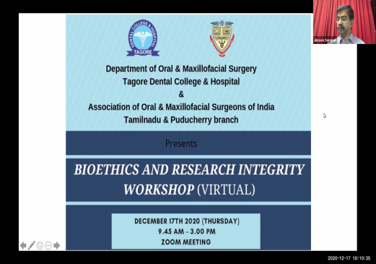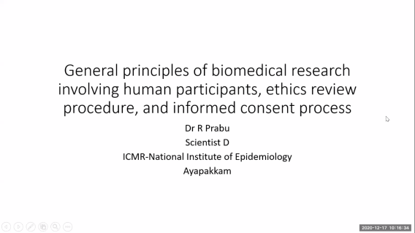

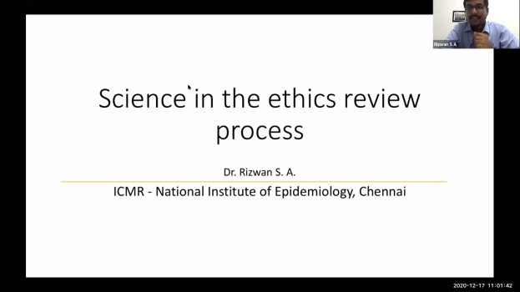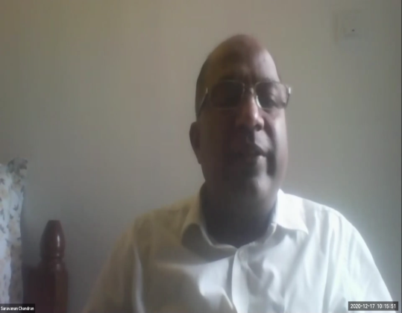

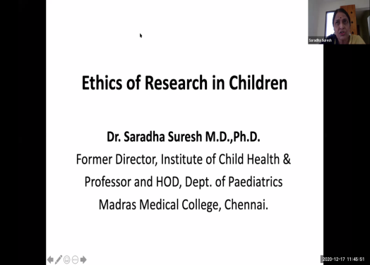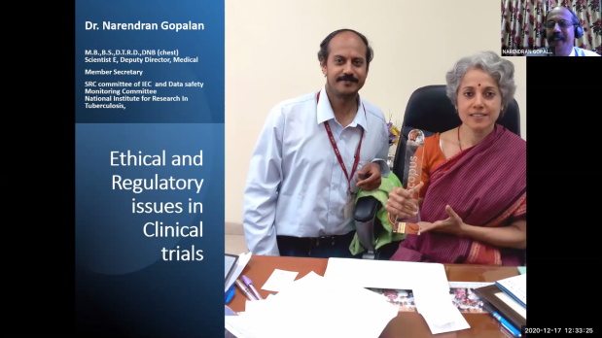

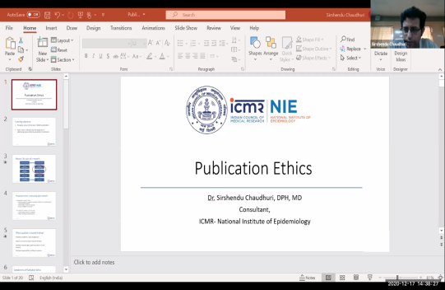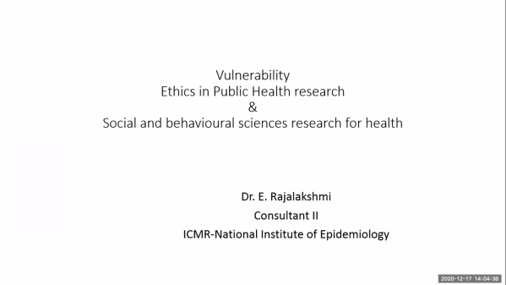

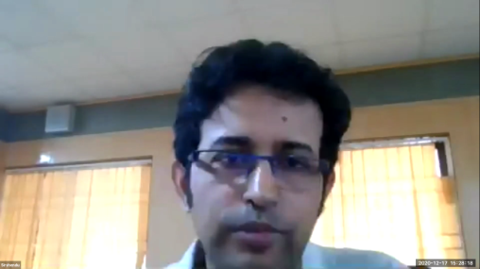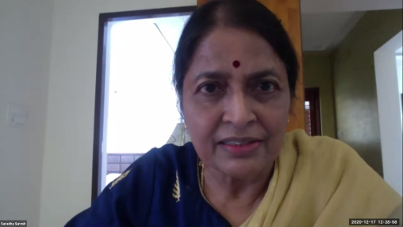

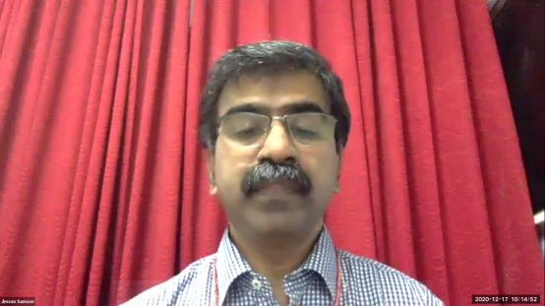

BIOETHICS AND RESEARCH INTEGRITY – VIRTUAL WORKSHOP 17/12/2021
ATTENDANCE :
DR.MURUGANANDHAN
DR.CHITRA .N
DR.HARSH DAVE
DR.NISHANTH KUMAR
DR.KARPAGAVALLI
DR.SANDHYA PAVANKUMAR
DR.R.PRAKASH
DR.SHASHIDARAN.P
DR.GEETHAPRIYA.P.R
DR.NUPUR KAPOOR
DR.OGIRALA SMYRNA
DR.ESTHER NALINI
DR.POOJA.K
DR.BHAVNA MALIK
DR.MANIKANDAN
DR.THIRU VIKRAMA NARAYANA
DR.KEERTHANA
DR.THANGAVELU
DR.GOLLU RAMESH
DR.M.REKHA
DR.TOMPALA VINOD KUMAR
DR.SURESH VYLOPILLI
DR.KANTHETI SIRISHA
DR.LEELA LAVANYA
DR.PREM KUMAR
DR.ASHOK KUMAR
DR.NIVETHA PRASANTHI
DR.SRILAKSHMI
DR.SUDHA JIMSON
DR.RAMA NALINI
DR.VIJAY ANIL KUMAR
DR.RADHA SINDUJA
DR.ARTHI
DR.GEETHA KUMAR
DR.PAVITHRA
DR.CHITRAA.R.CHANDRAN
DR.BHUVANESHWARI
DR.PARTHASARATHI
DR.R.PRIYADHARSHINI
DR.JUALA CATHERINE

41. | DR.SAI KRISHNA
42. | DR.L.S.MAKESH RAJ
43. | DR.JAI SANTHOSH
44. | DR.PRASANNA
45. | DR.ASOKAN
46. | DR.DEEPIKA.C
47. | DR.JAYAPRAKASH
48. | DR.LAKSHMI PRIYA
49. | DR.K.GAYATHRI
50. | DR.VAISHNAVI
51. | DR.KUMARA RAJA.B
52. | DR.VANDHANA JAMES
53. | DR.GEETHA PRIYA
54. | DR.C.S.SHOBANA
55. | DR.SRIVIGNESH
56. | DR.ANISHA SEBATNI
57. | DR.C.CHARANYA
58. | DR.SARATH SARATHY
59. | DR.SARATH KUMAR
60. | DR.BALAJI.K
61. | DR.SUNIL CHANDY
62. | DR.MAHALAKSHMI.K
63. | DR.R.RAJESH
64. | DR.SHANTHINI PRIYA
65. | DR.PARAMESWARAN
66. | DR.VENKATAKRISHNAN
67. | DR.JACOB MATHEW PHILIP
68. | DR.NARASIMMAN
69. | DR.RATHINAVEL PANDIAN
70. | DR.HELEN MARY ABRAHAM
71. | DR.NITHIYARAJAN
72. | DR.TAMIZHESAI
73. | DR.S.JIMSON
74. | DR.LOKESH.B
75. | DR.MEERAN SHARIF
76. | DR.VINAY SUNDAR
77. | DR.ISRAEL NATHANAEL

78. | DR.BHARATH KUMAR.B
79. | DR.GOWTHAM.S.T
80. | DR.KEERTHI.P
81. | DR.PANDIYARAJAN
82. | DR.HARI VIGNESH.S
83. | DR.MOHAN KUMAR.A
84. | DR.SABARI.V
85. | DR.ARCHAYA.M
86. | DR.BALAJI ANANDH.S.D
87. | DR.PAVITHRA.B
88. | DR.SAHANA.R
89. | DR.VIDHYASHREE.M
90. | DR.DHATSHAYANI.C
91. | DR.DEEPSHI.M
92. | DR.ARRVINTHAN
93. | DR.SHANKAR
94. | DR.BHEEMISTTY
95. | DR.SUJAREETHA.A
96. | DR.NIVEDHITHA.V
97. | DR.RAVEENDHARAN.K
98. | DR.ARUN PRAKASH
99. | DR.NAZRIN.M
100. | DR.VASHNI.S
101. | DR.DIVYADHARSHINI.K.P.R
102 | DR.KALAISELVI
103 | DR.NAVABHARATHY.V
104 | DR.BHARATH KUMAR
105 | DR.FAHAD AHMED.S
106 | DR.RAGHUL.G.P
107 | DR.VAANMUGIL.J

